Name Teesha kumari
CMS:023-23-0195
LAB task Machine learning
Section A — Python (Q1–Q10)

Task 1
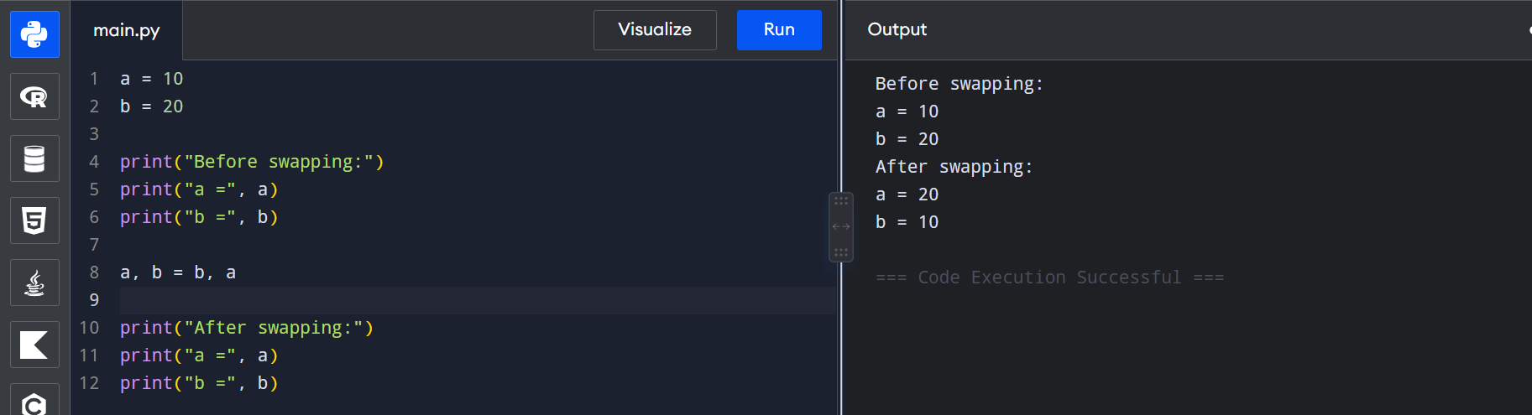

Task 2

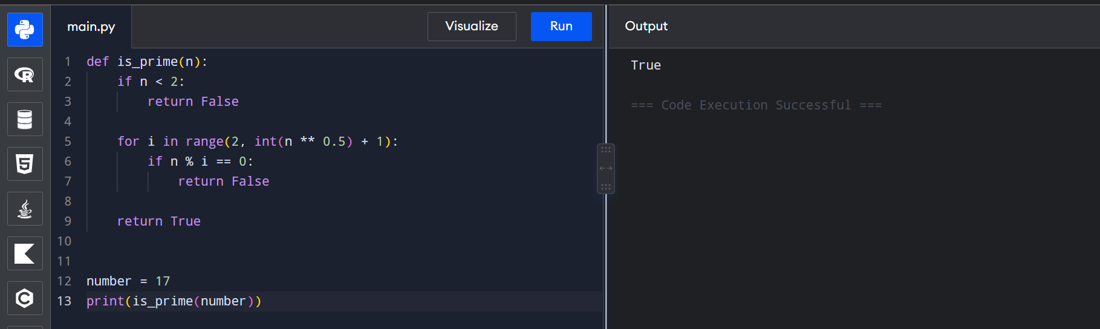

Task 3
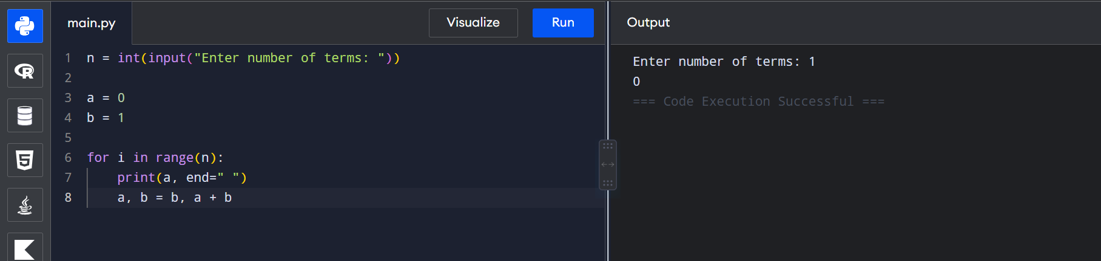
Task 4
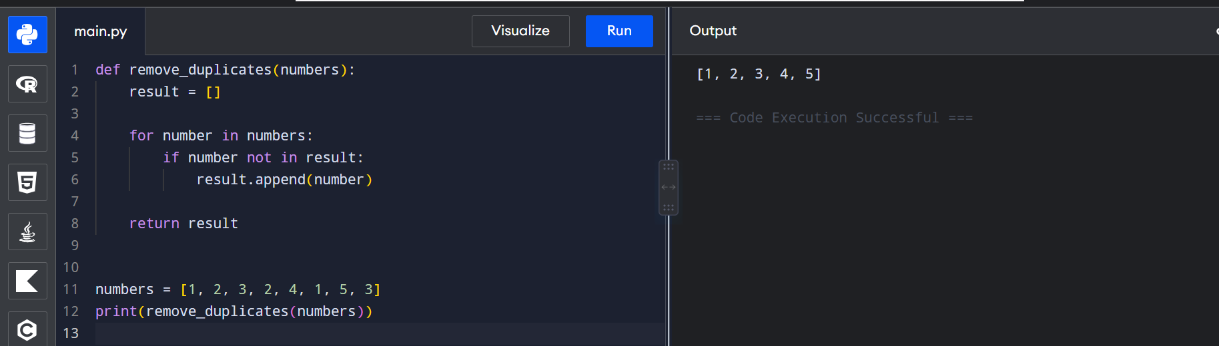
Task 5
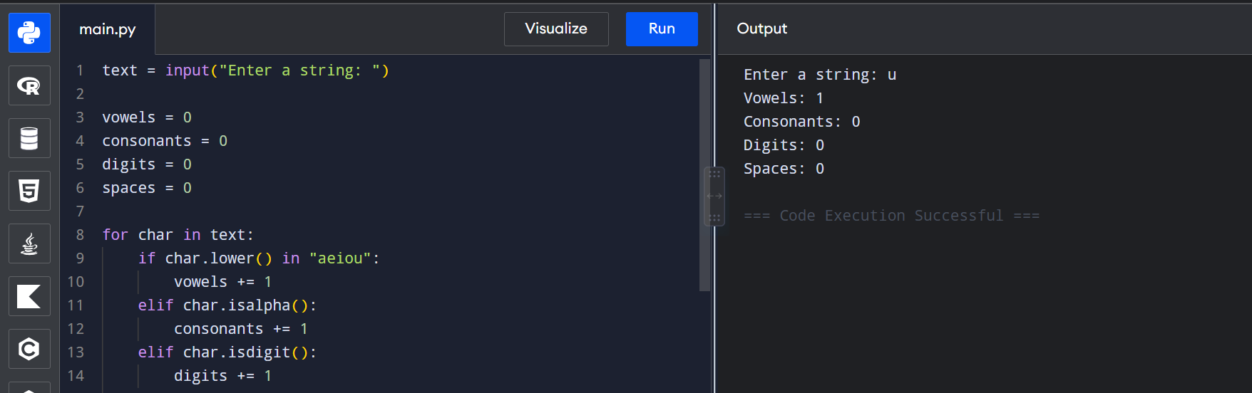
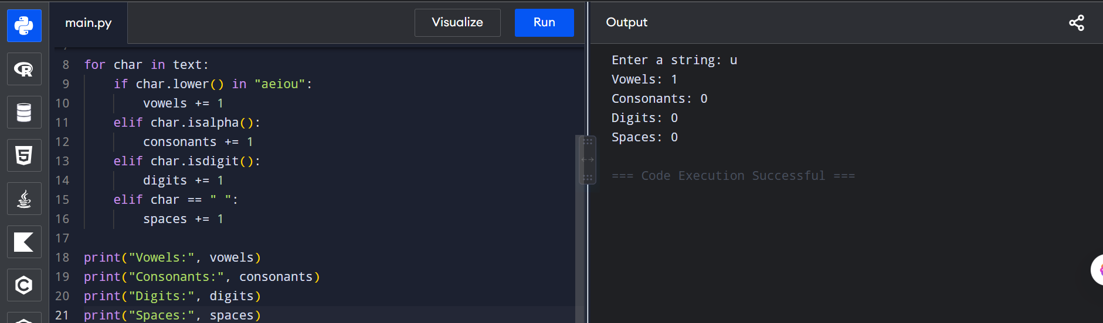

Task 6
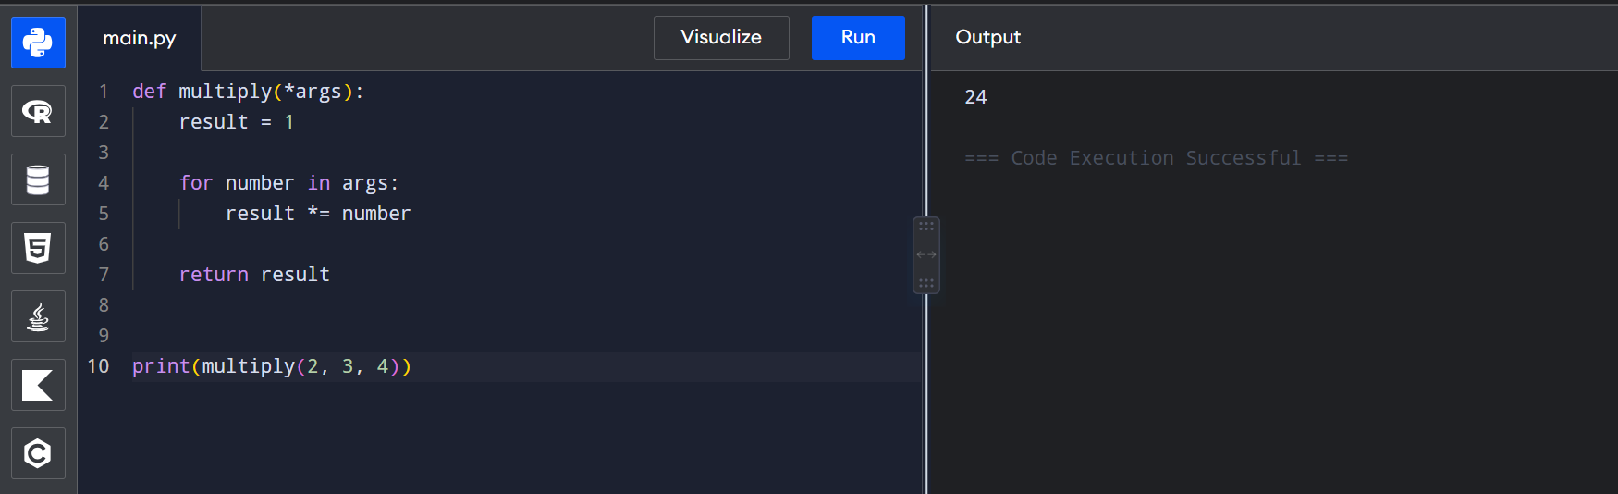

Task 7
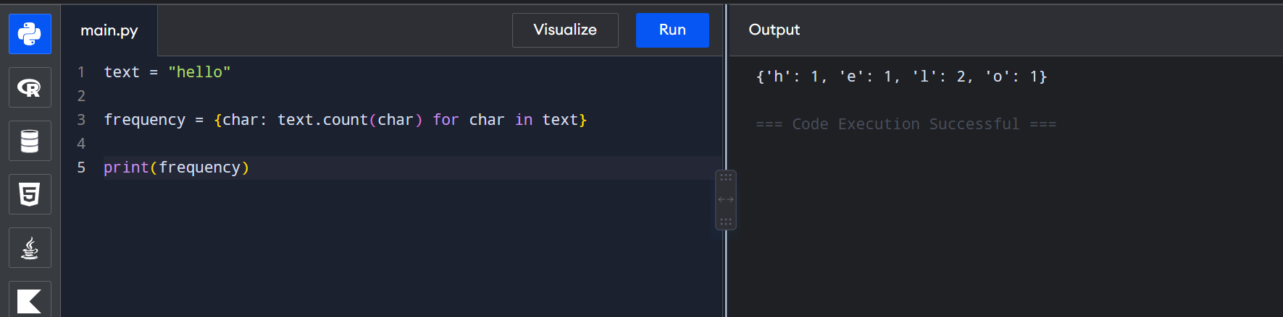

Task 8
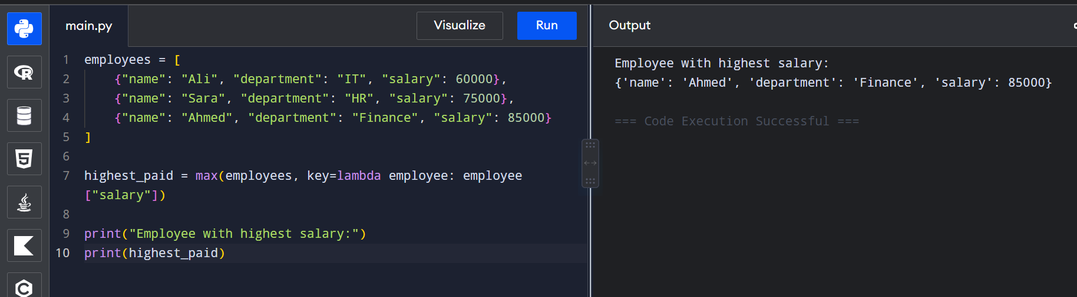
Task 9
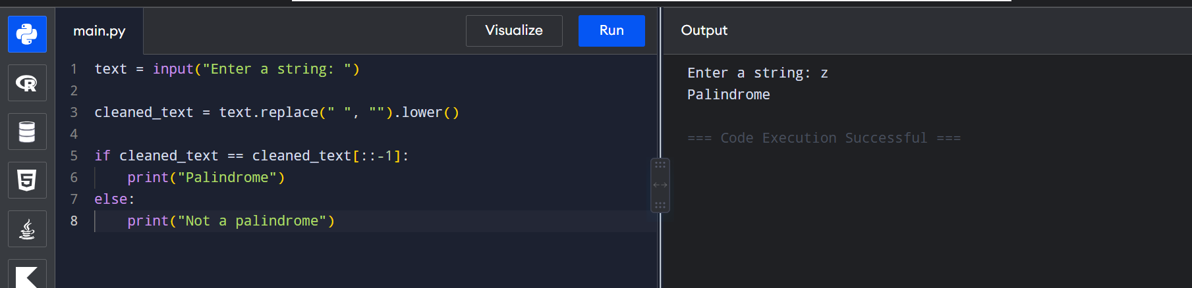
Task 10
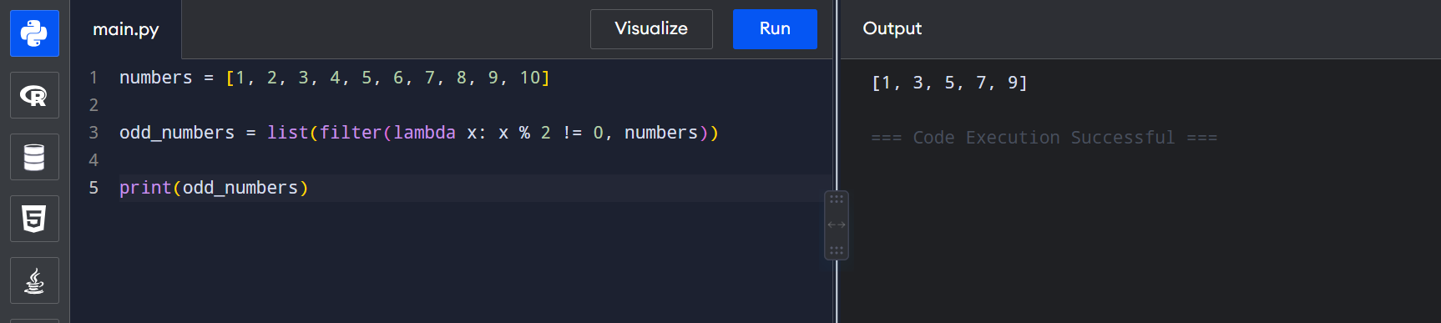

Section B — NumPy (Q11–Q25)

Task 11
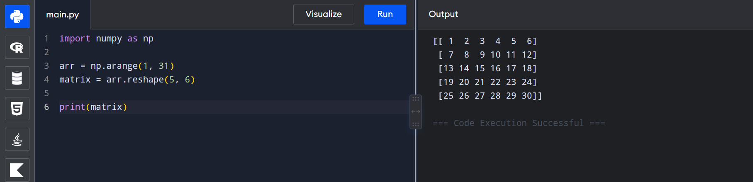
Task 12
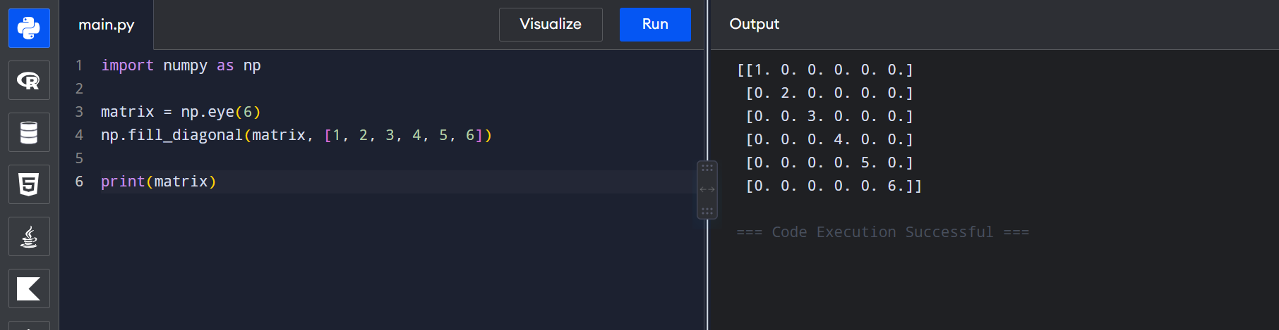

Task 13
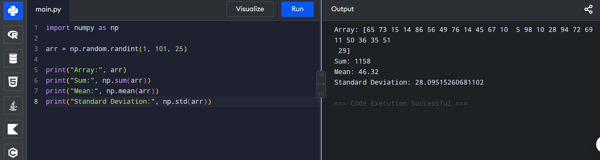
Task 14
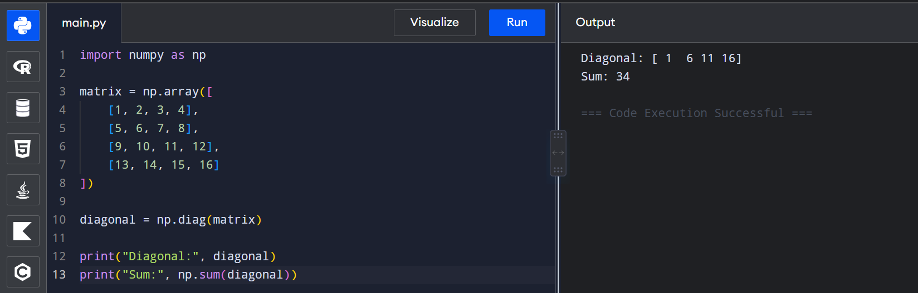
Task 15
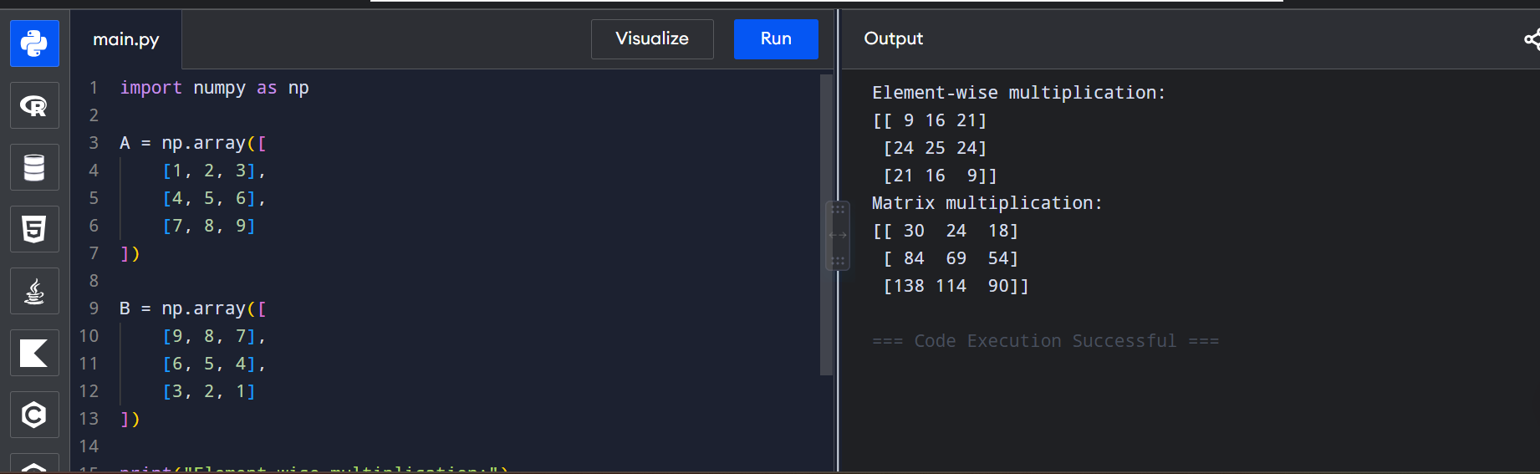
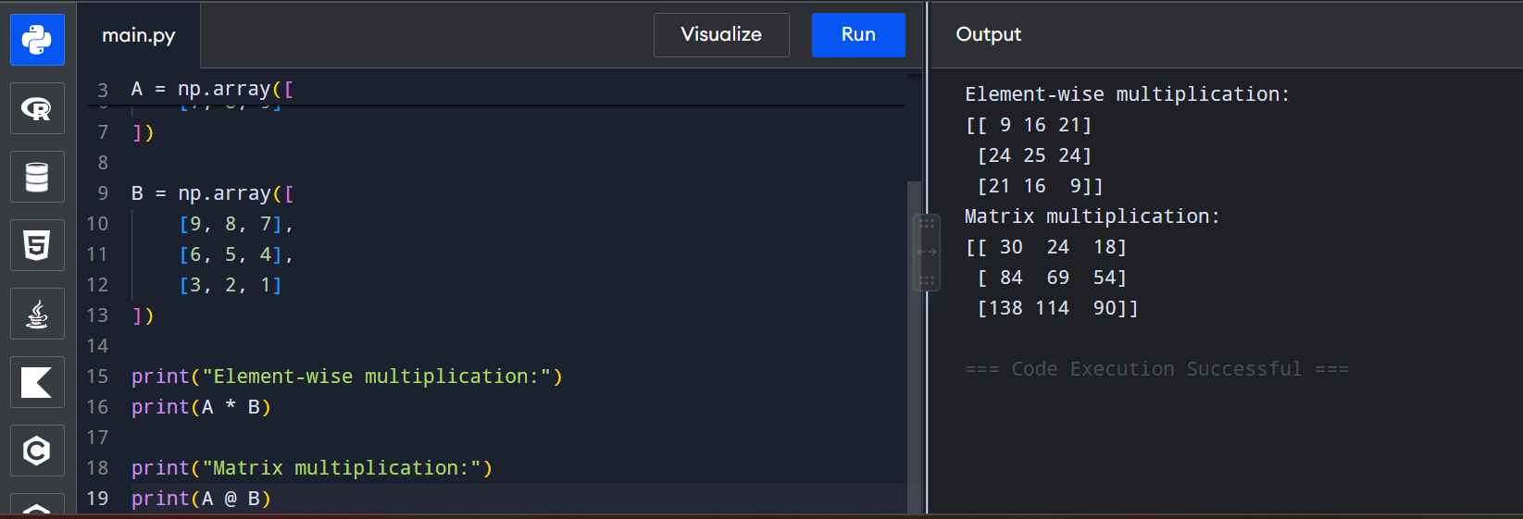
Task 16
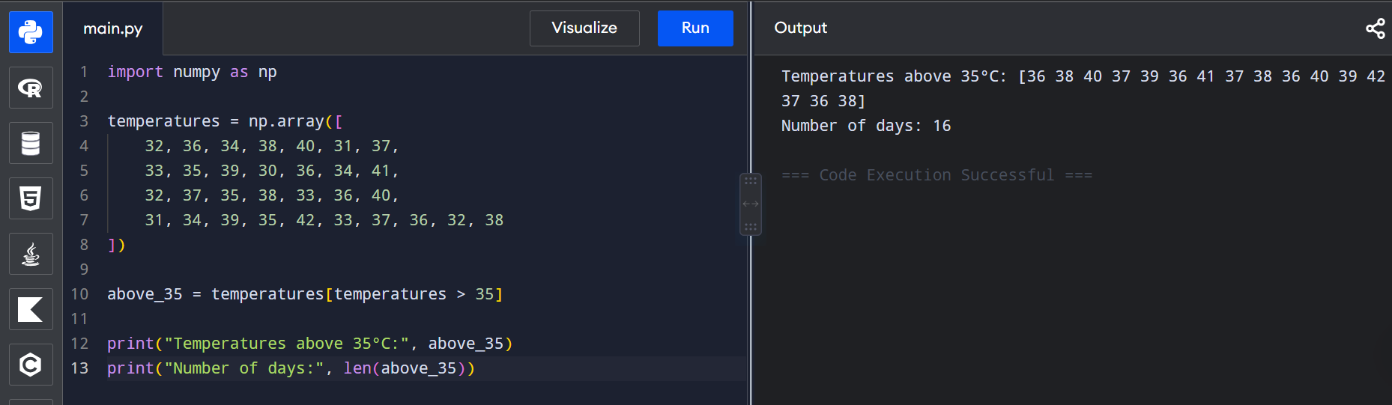

Task 17
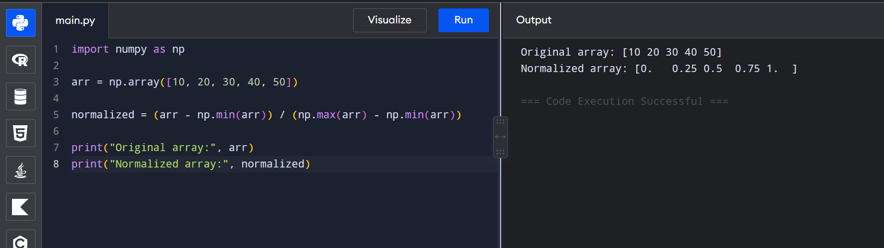

Task 18 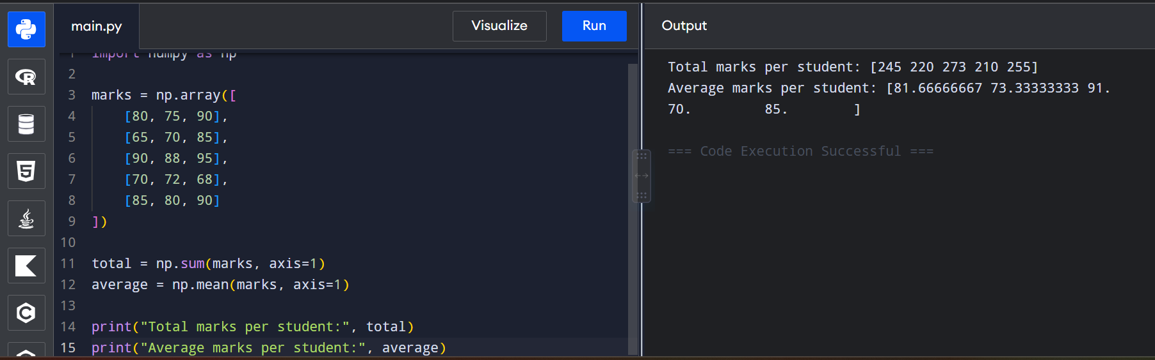

Task 19
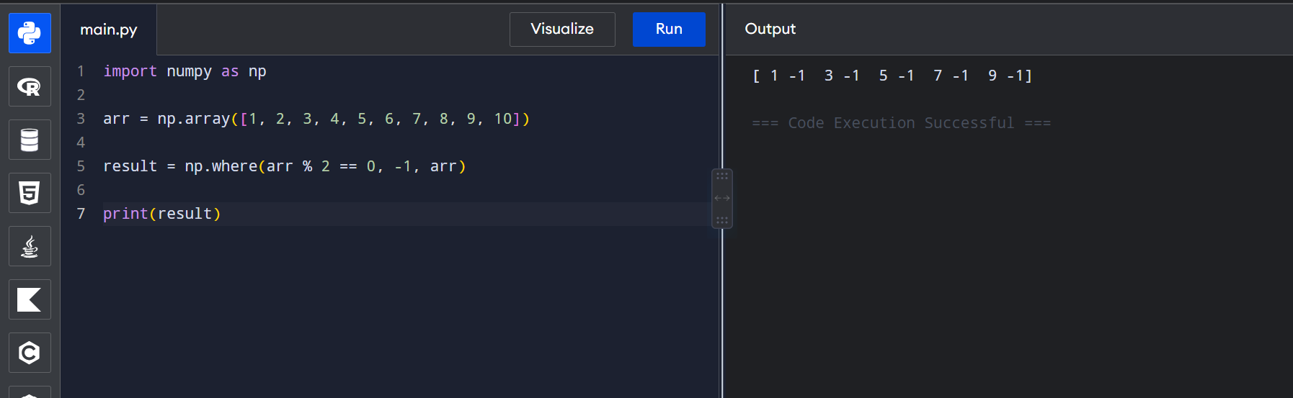
Task 20
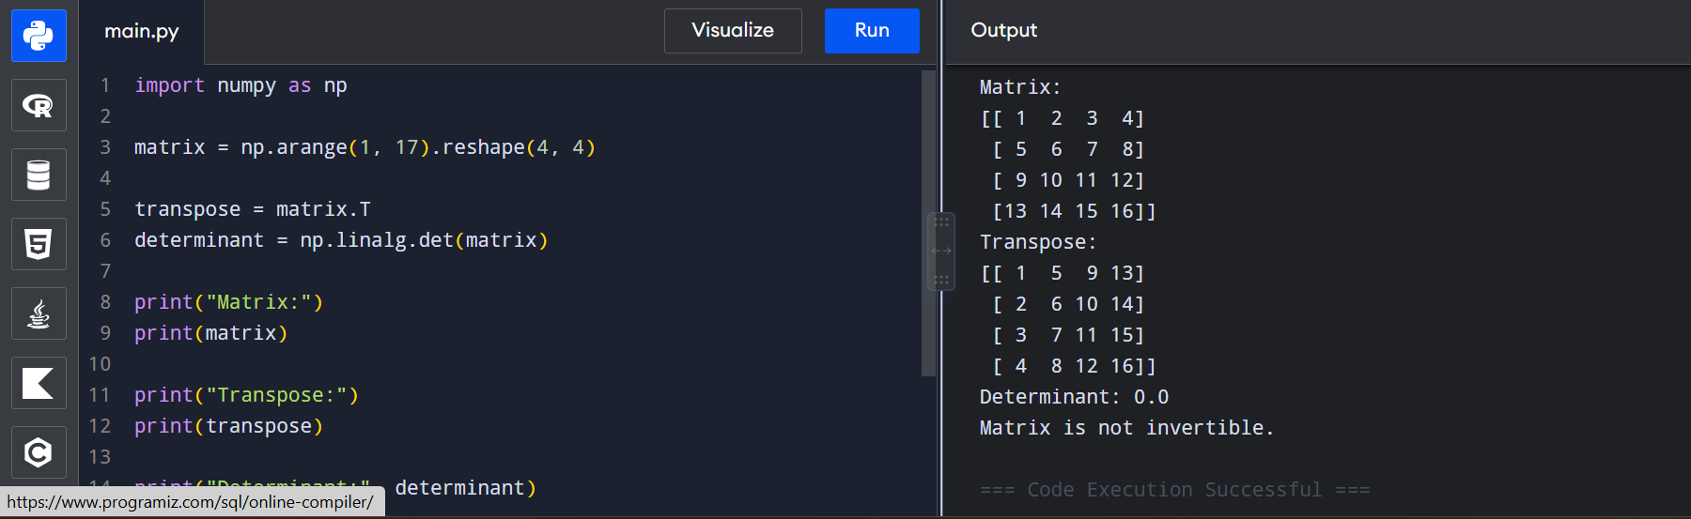
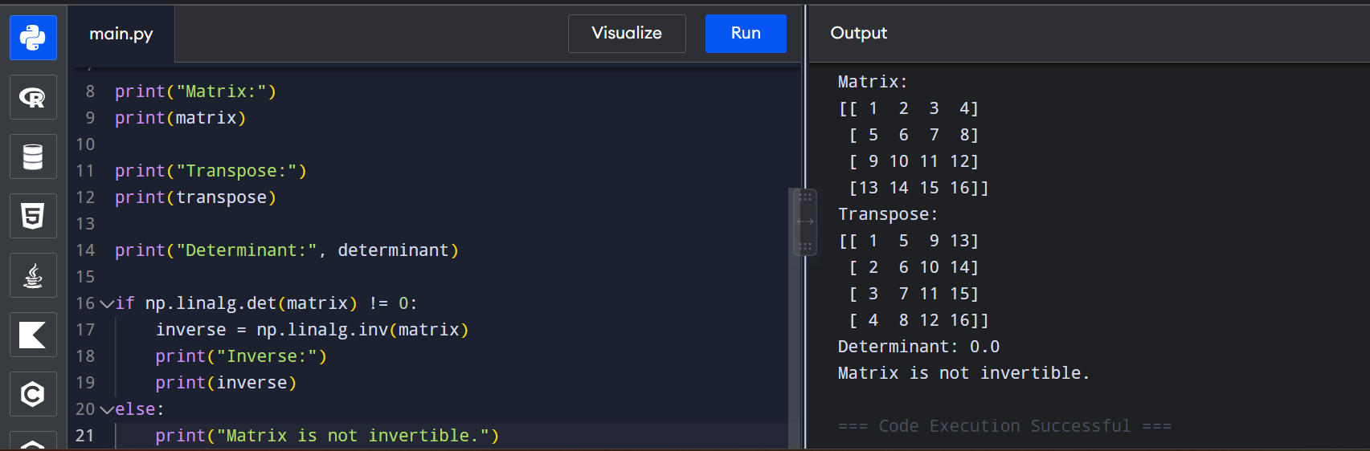

Task 21
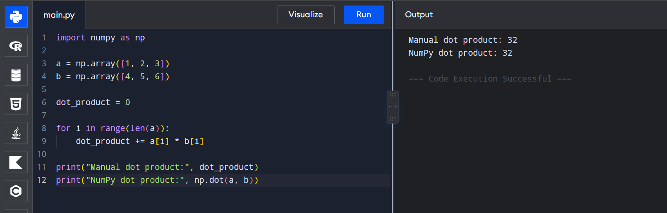
Task 22
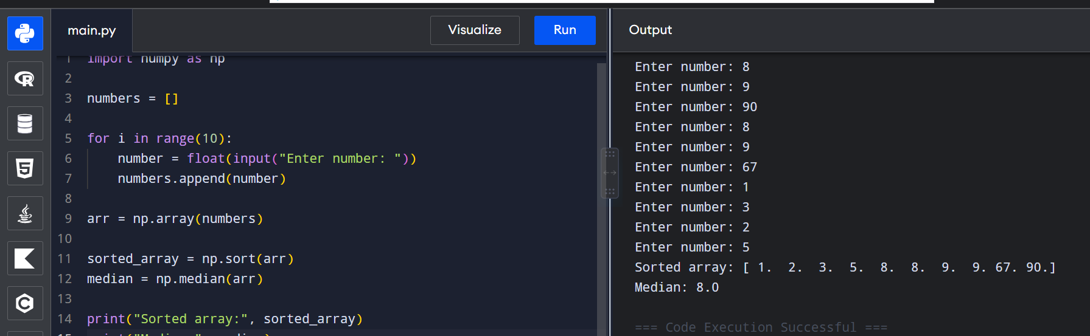

Task 23
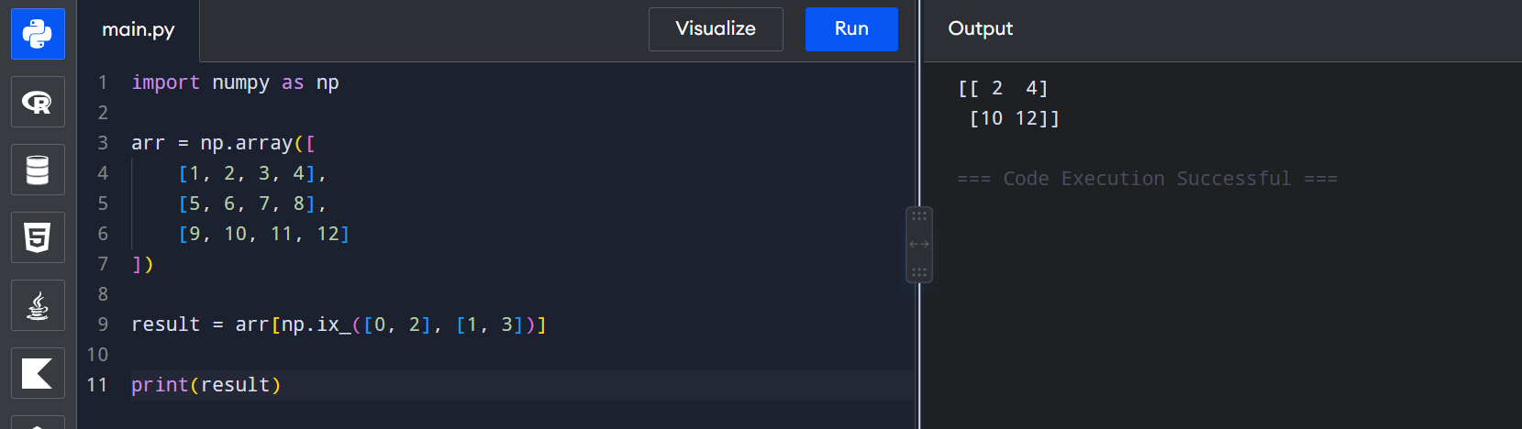
Task 24
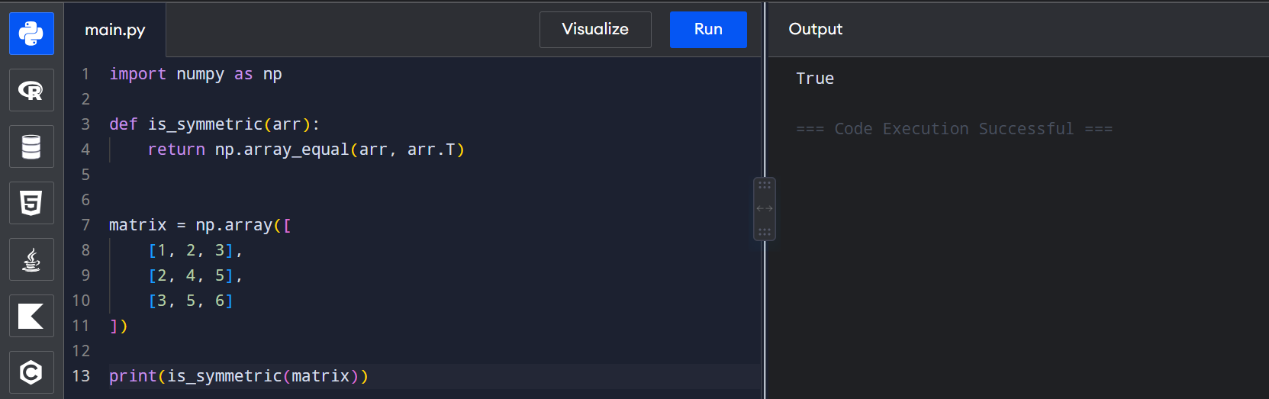

Task 25
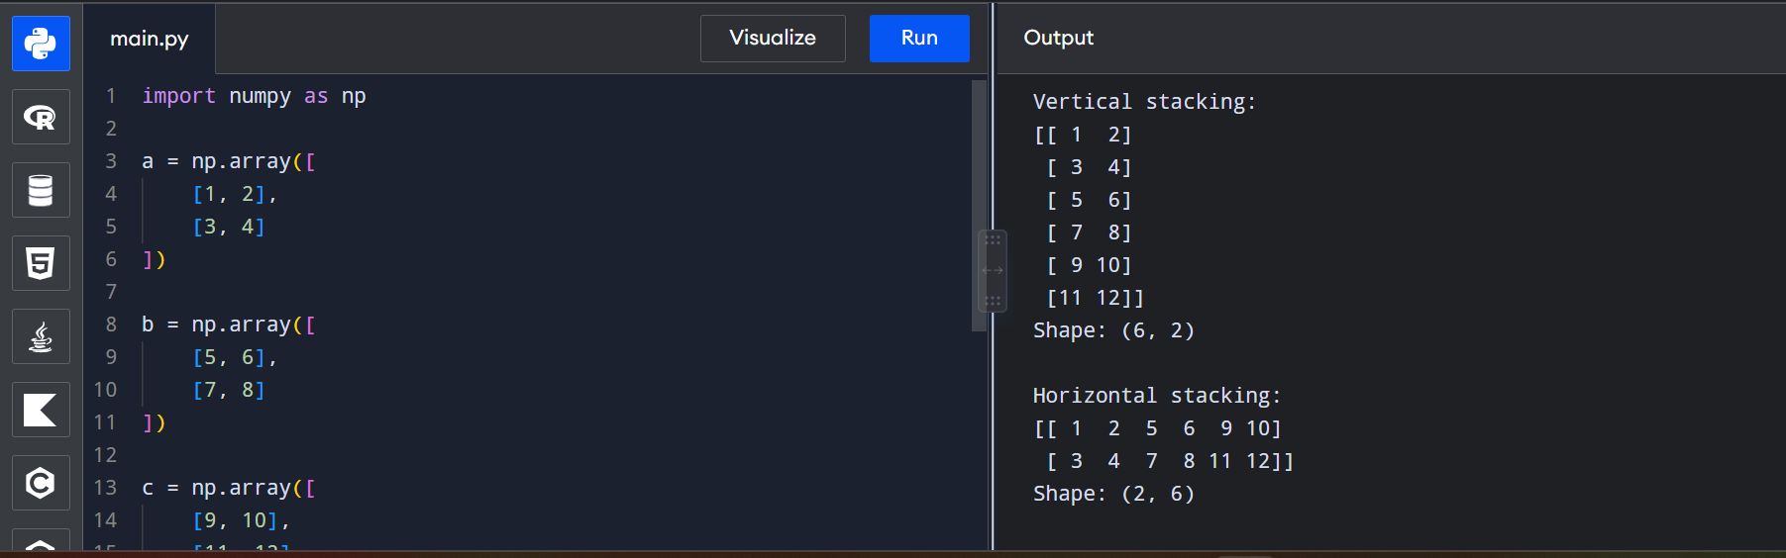
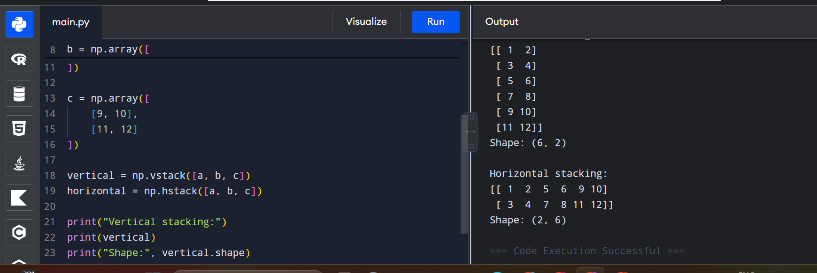
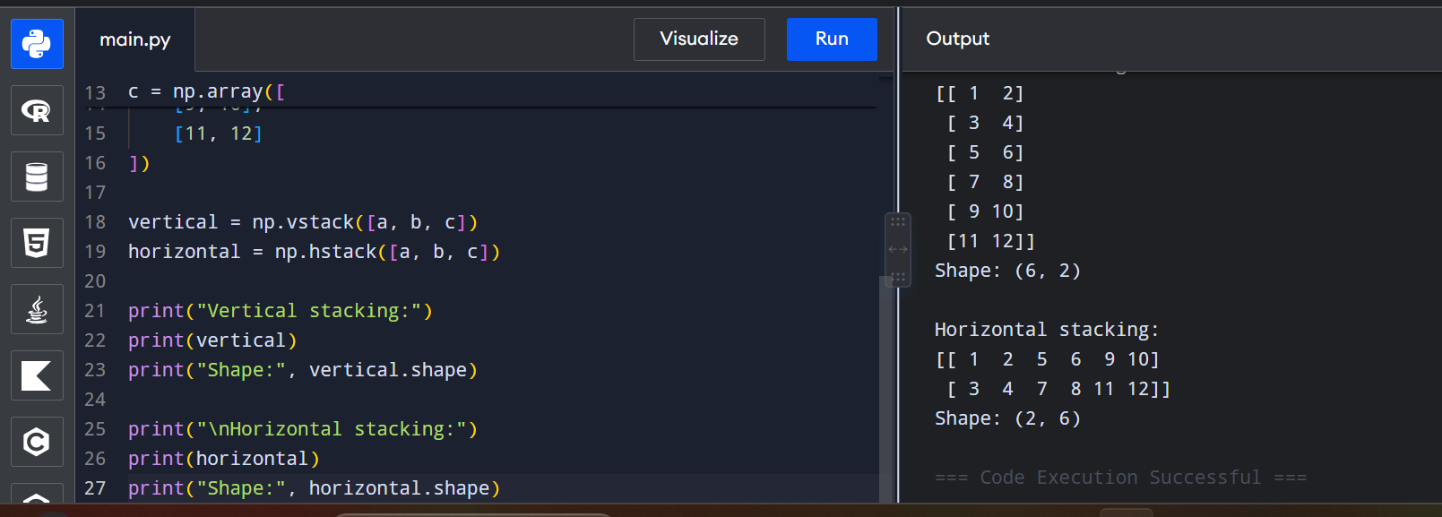
Section C — Matplotlib & Pandas (Q26–Q35)

Task 26
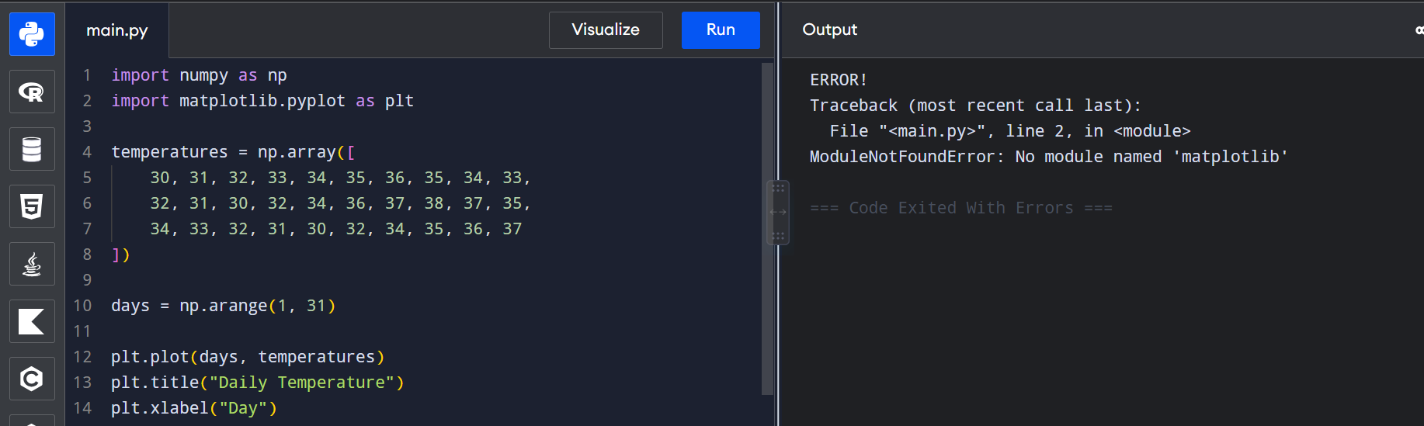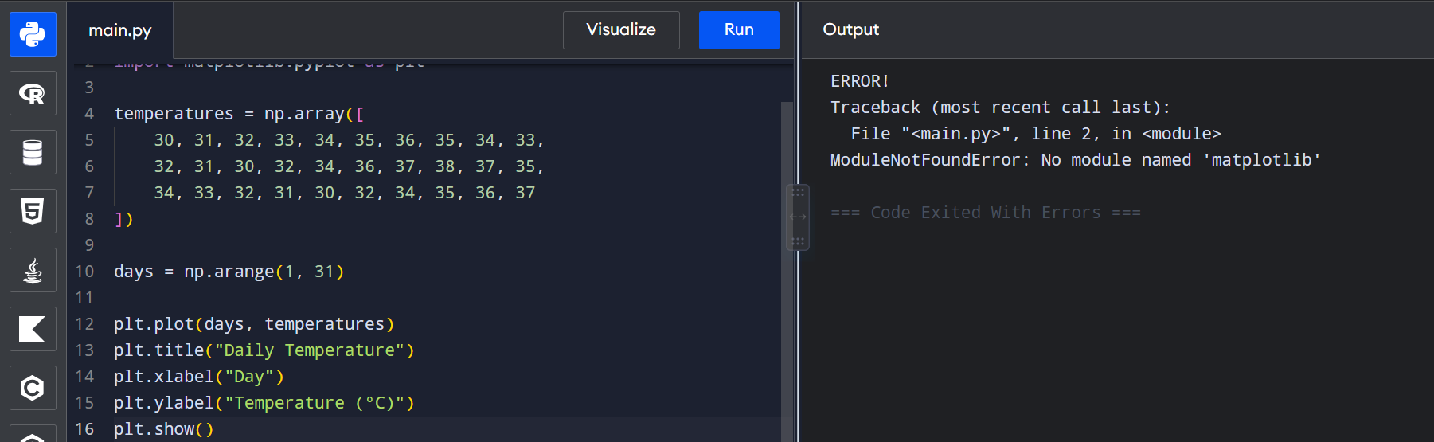
Task 27
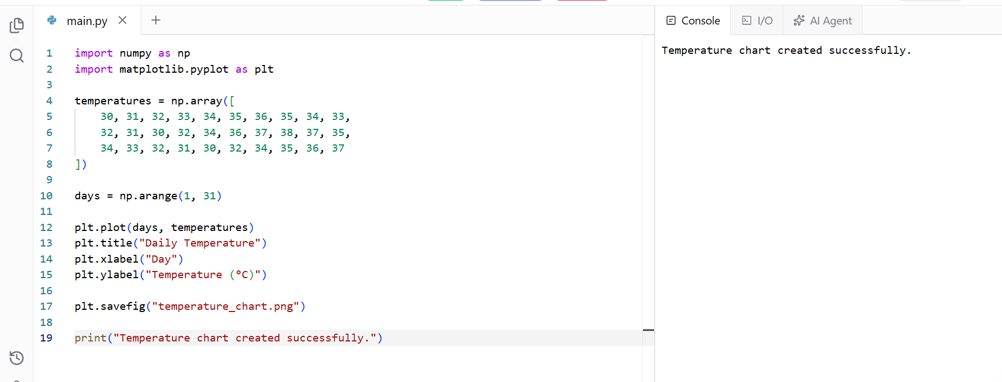

Task 28
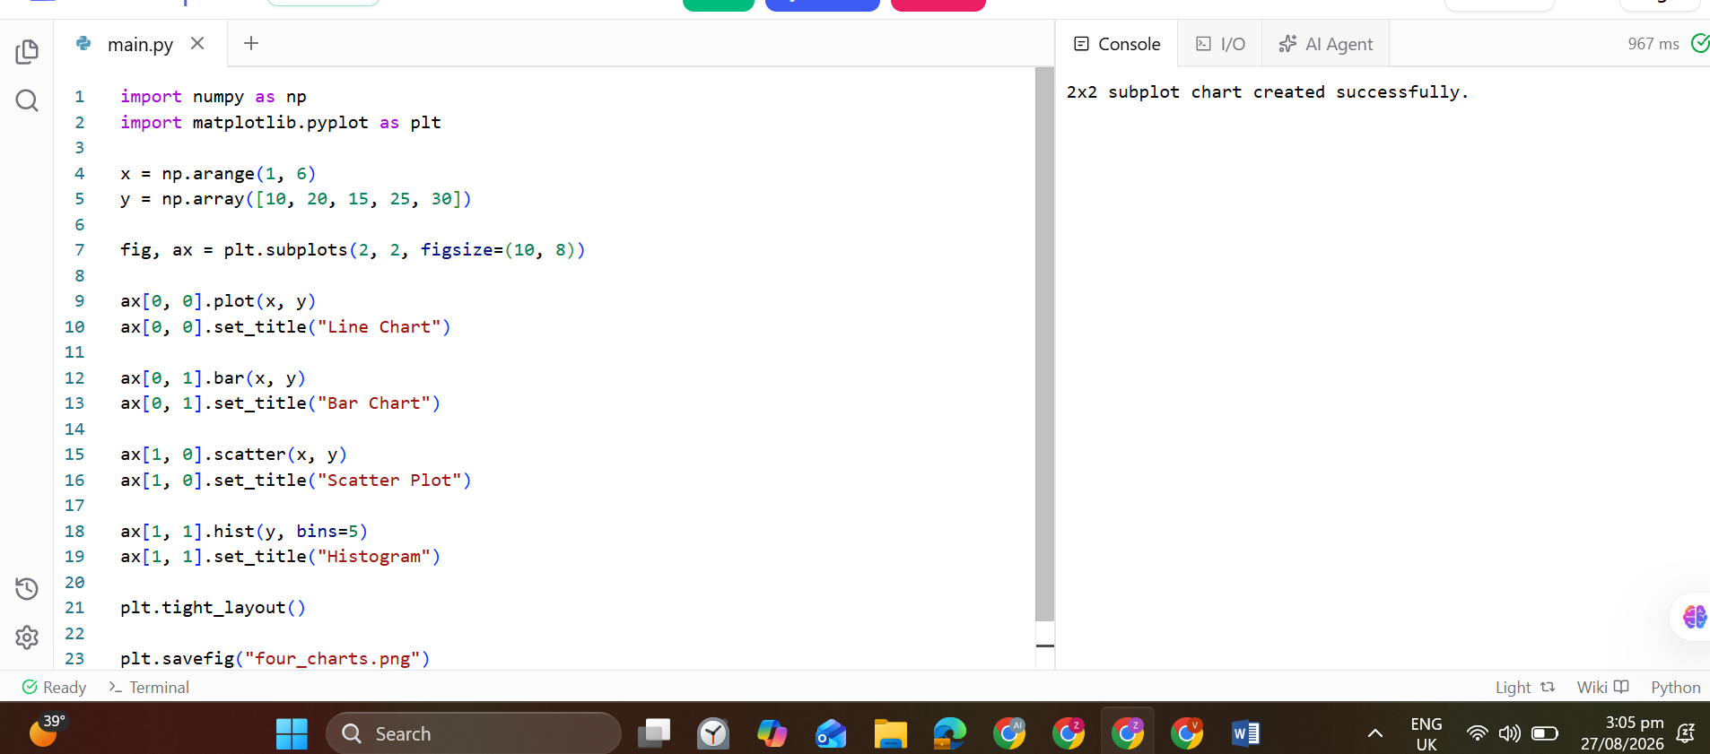

Task 29
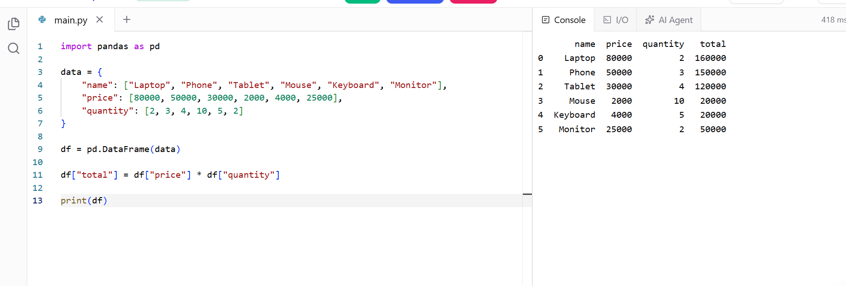
Task 30
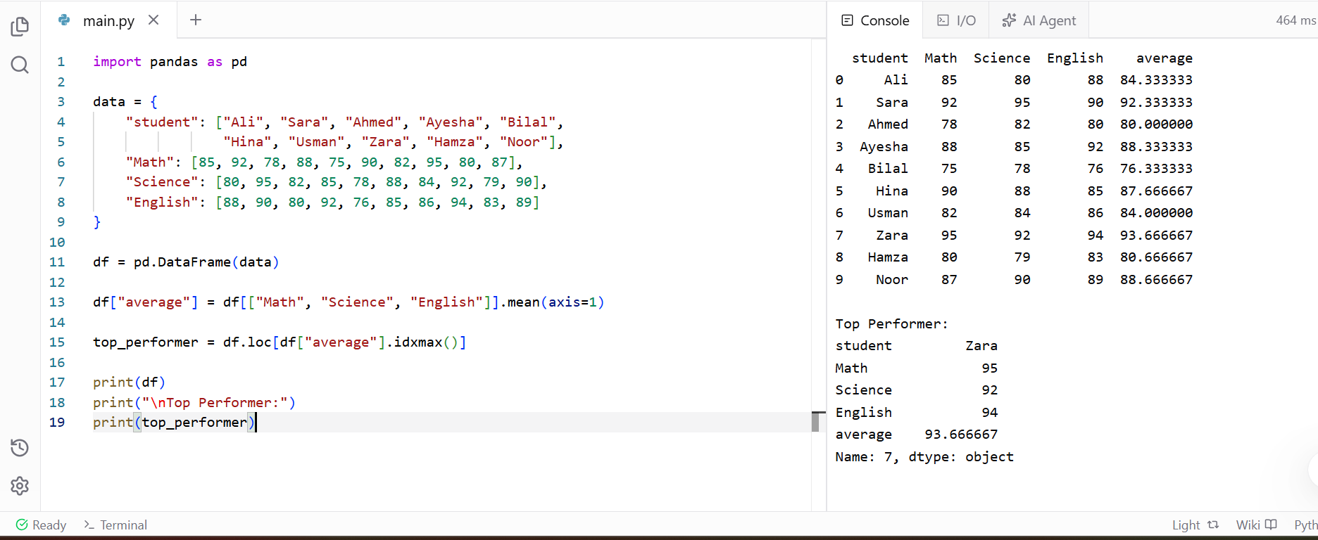
Task 31
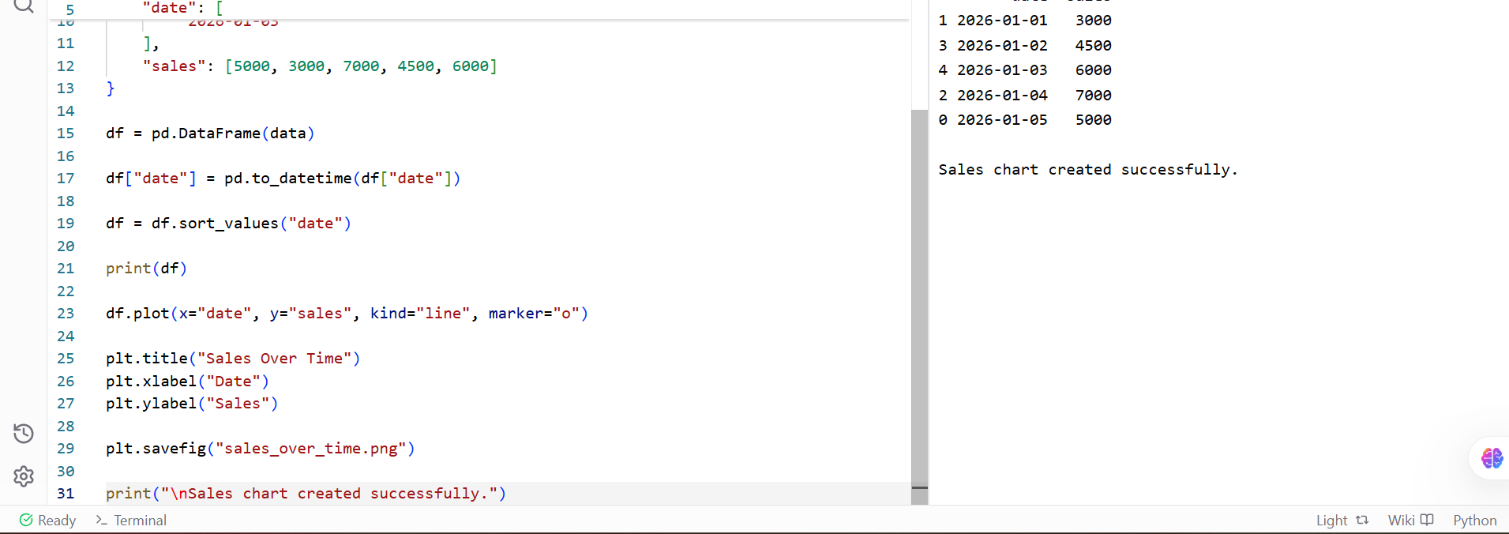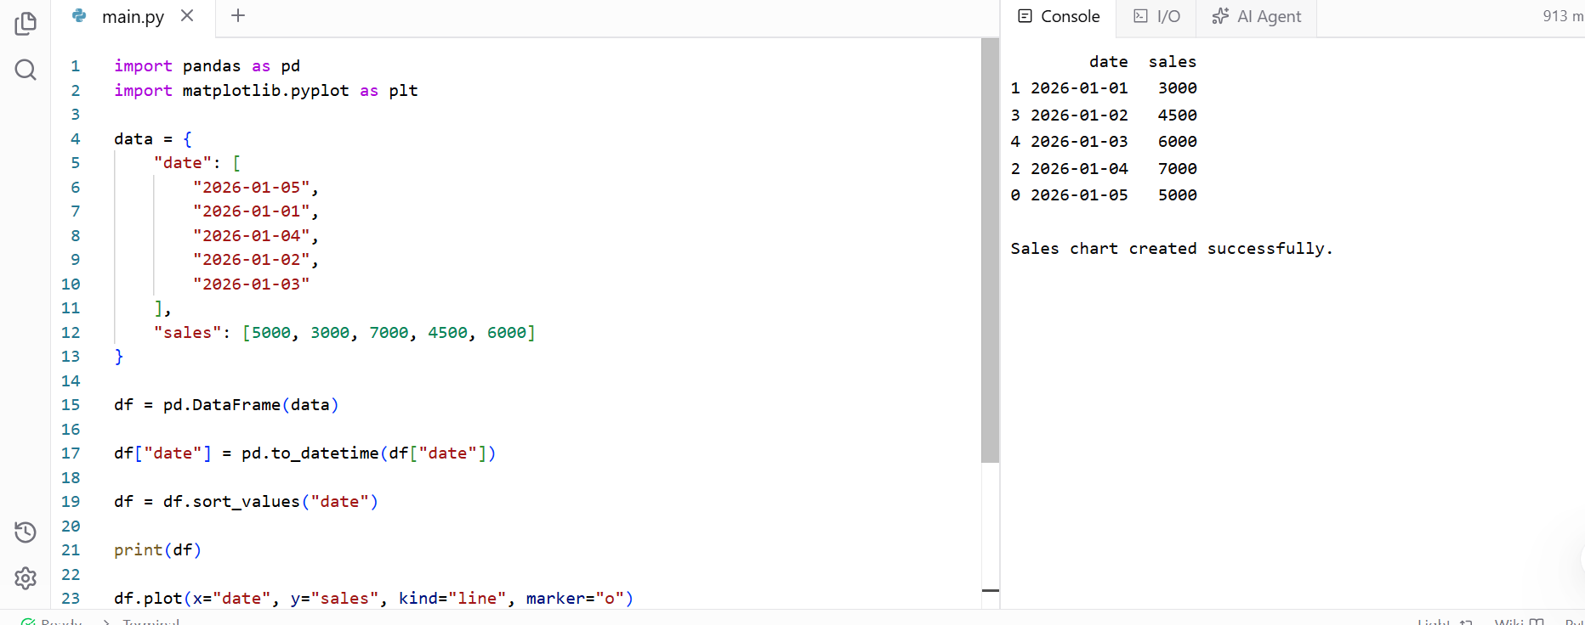

Task 32
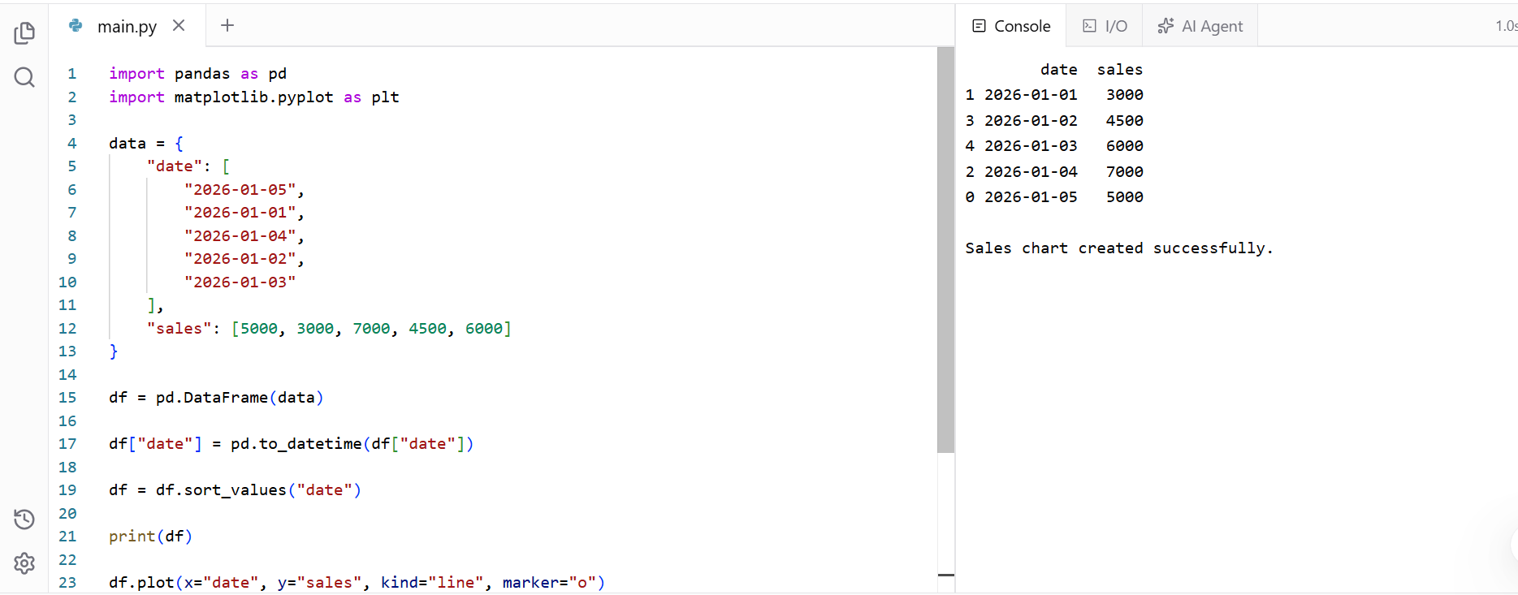
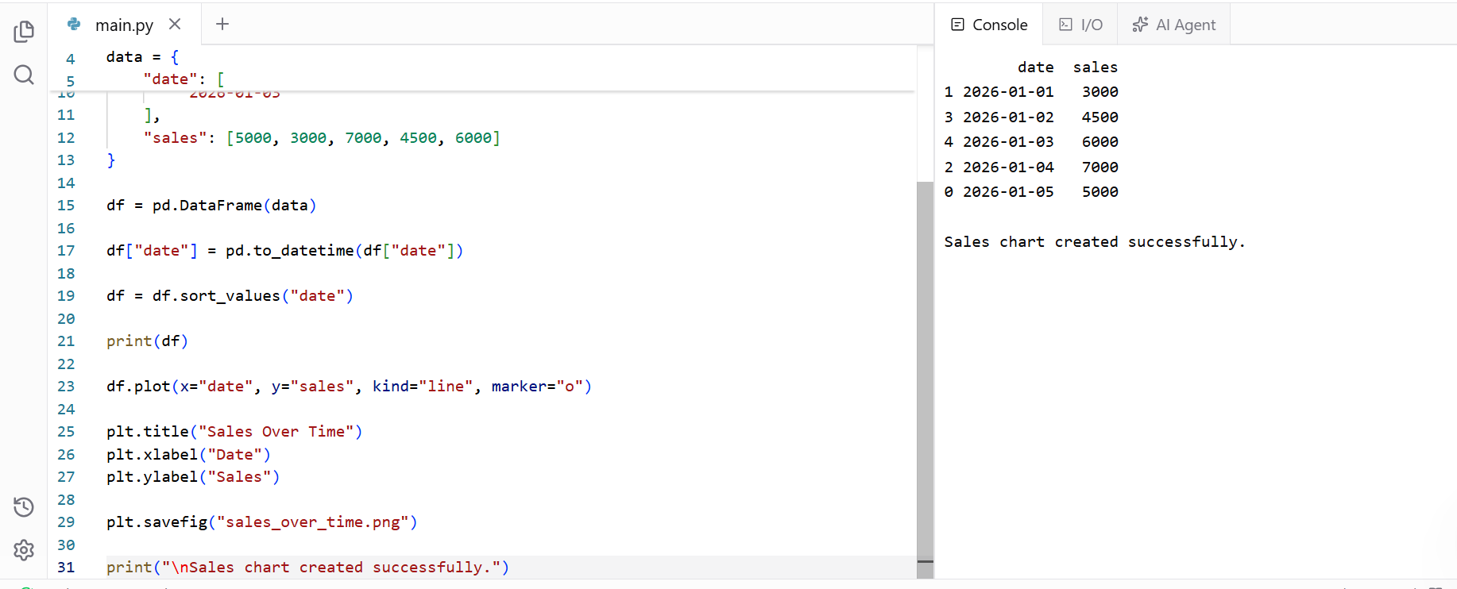
Task 33

Task 34
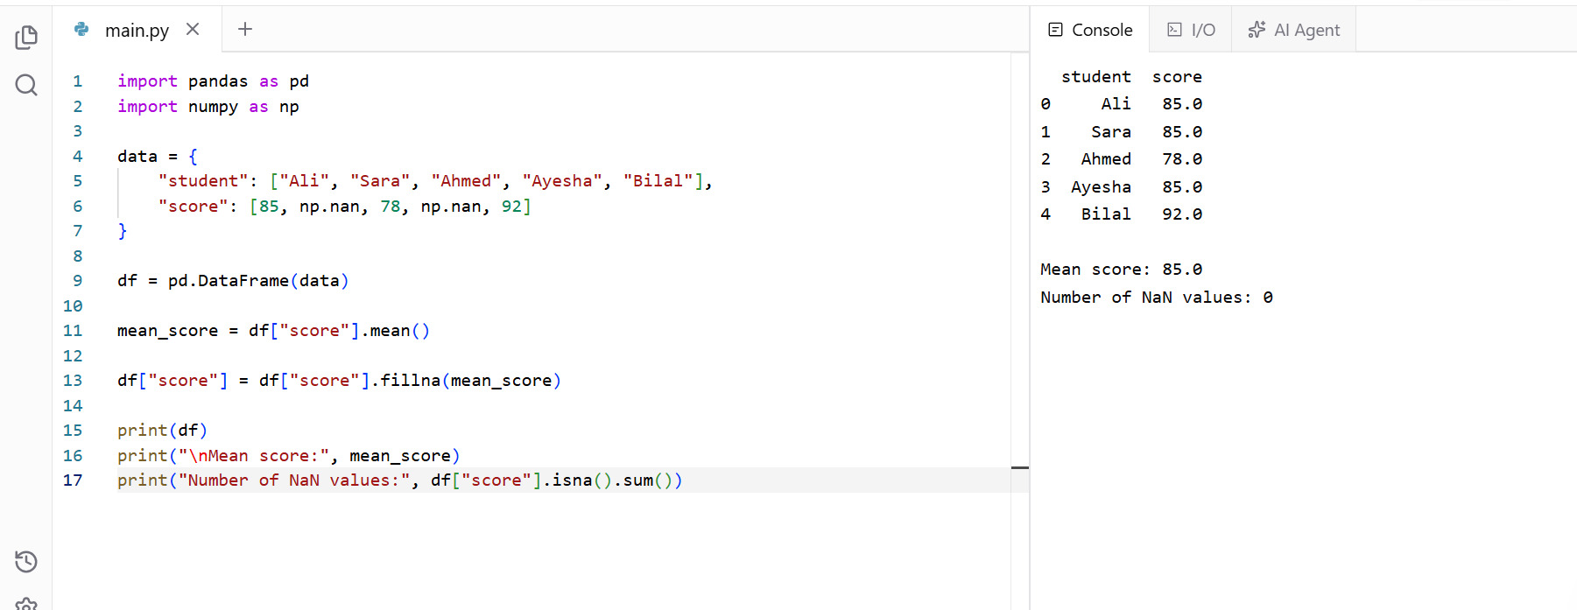
Task 35
